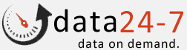
Data 24-7 package Installation Guide

Revision History
Author | Revision Number | Date
Saurabh Gupta | 1.0 | 2015-08-14

STEP -1 Installing Package
- Login to salesforce account.
- Install the package from the url below. (https://login.salesforce.com/packaging/installPackage.apexp?p0=04t1a000000VKqt)
in browser and press enter.
- Follow the instructions given on screen and click Install button.

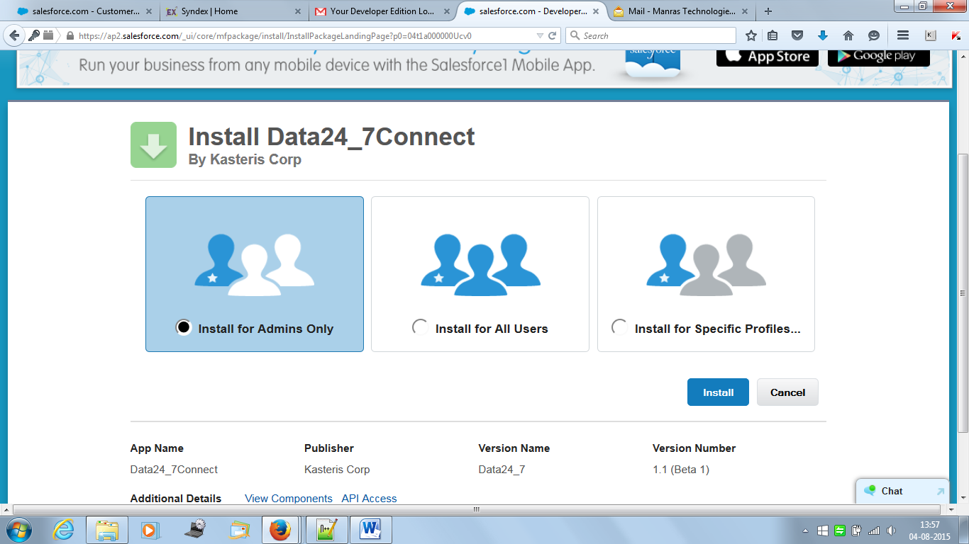

- Select ‘Install for Admins Only’(as per requirement).
- Click Install button.

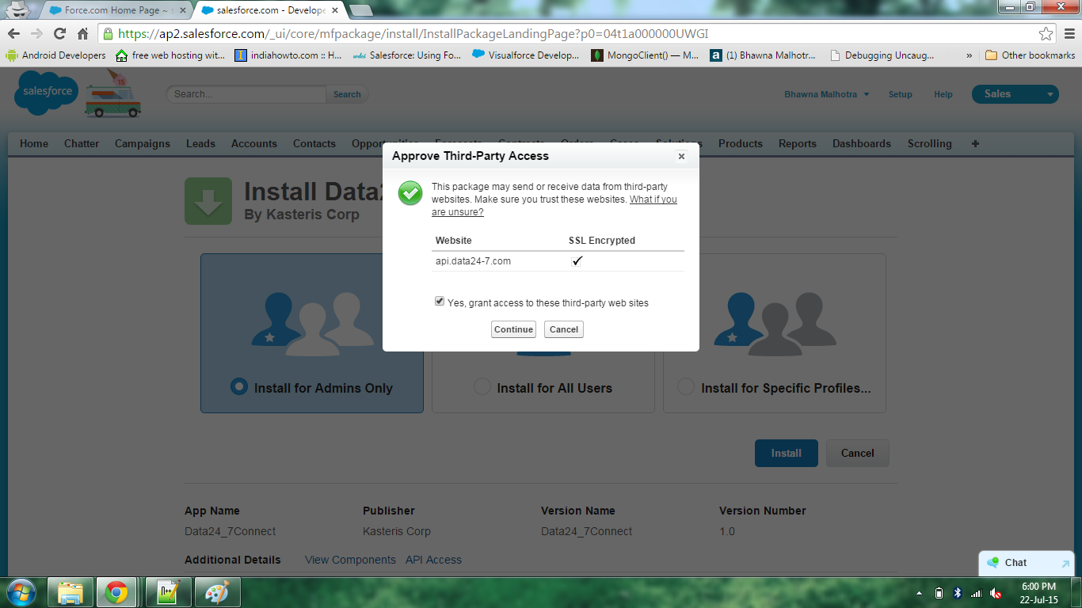

- Select ‘Yes Grant Access to these third party web sites’.
- Click Continue button.
- Then click Done then installation is complete.

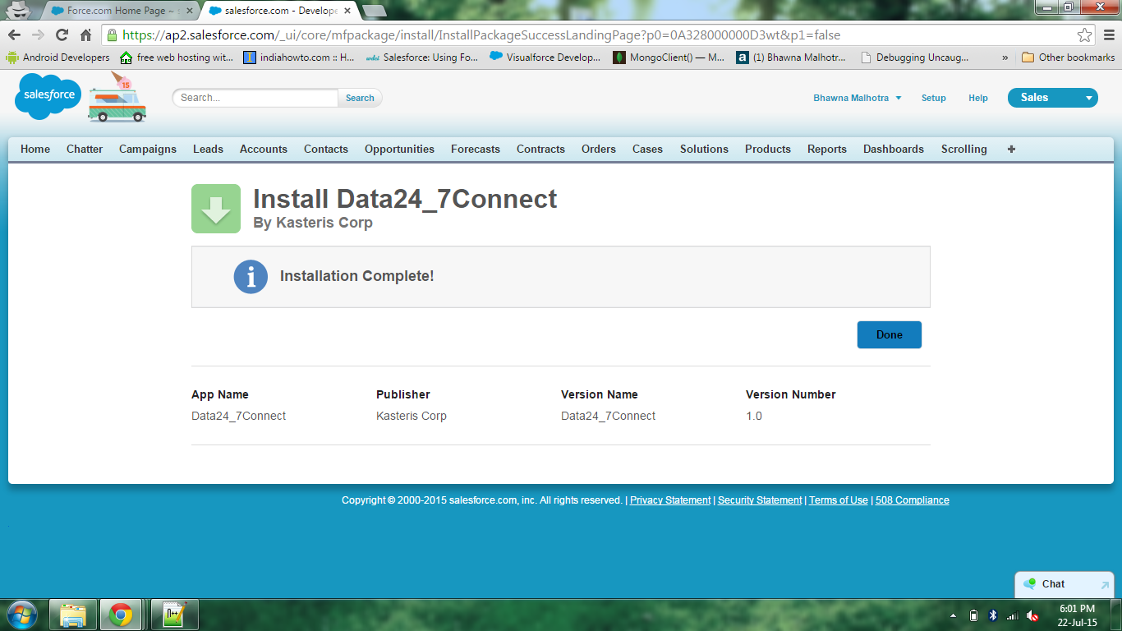

- Now Package is Installed.

Data 24/7 Setup for Contacts
STEP-2 Editing Page Layouts
- Setup->Build->Customize->Contacts->Search Layouts
- Edit (Contacts List View)
- Add Data24-7 Connect from Available Buttons to Selected Buttons.
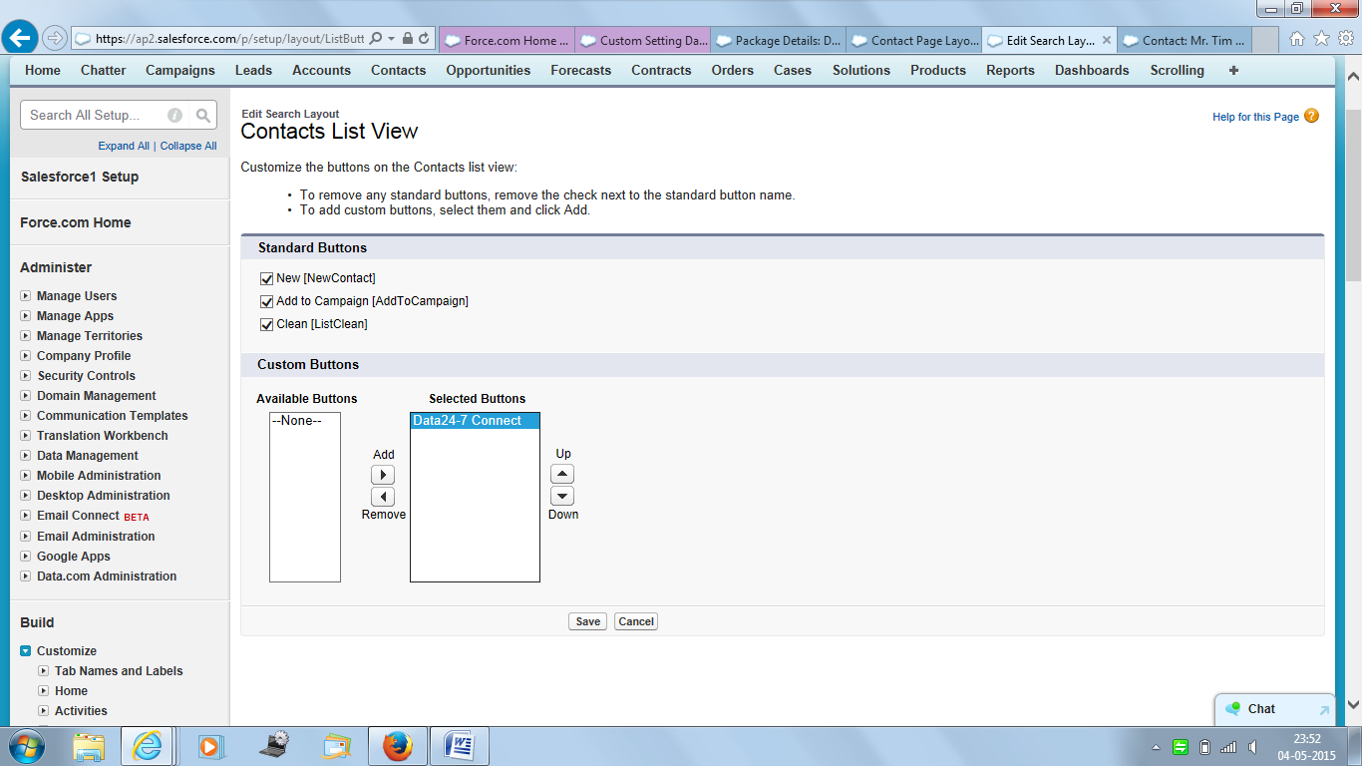
Add Data24-7 Connect
Save
- Setup->Build->Customize->Contacts->Page Layouts
  - ->Click Edit(Contact Layout)
- Select Fields
- Add Carrier Id, Carrier name ,Wireless , MMS Address ,SMS Address to Contact Information Section.
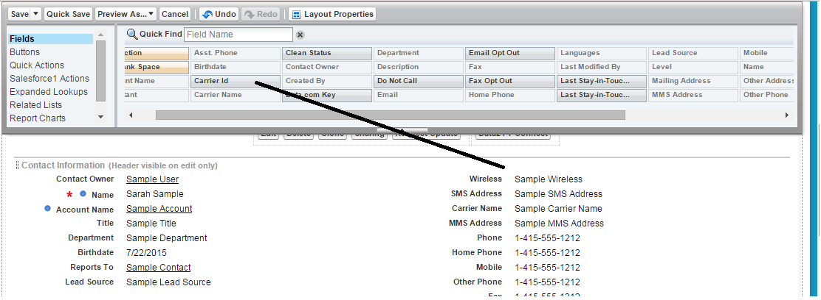

- Select Buttons
- Add Data24-7 Connect button to Custom Buttons of Contact Detail Page.
- Click Save
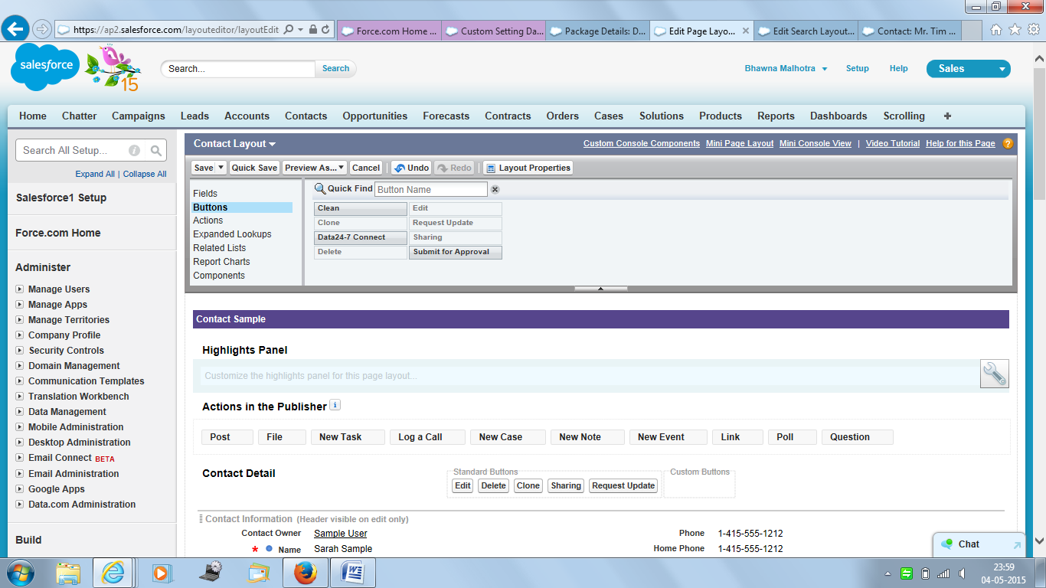
Add Data24-7 Connect Button

Data 24/7 Setup for Leads
STEP-2 Editing Page Layouts
- Setup->Build->Customize->Leads->Search Layouts
- Edit (Leads List View)
- Add Data24-7 Connect from Available Buttons to Selected Buttons.

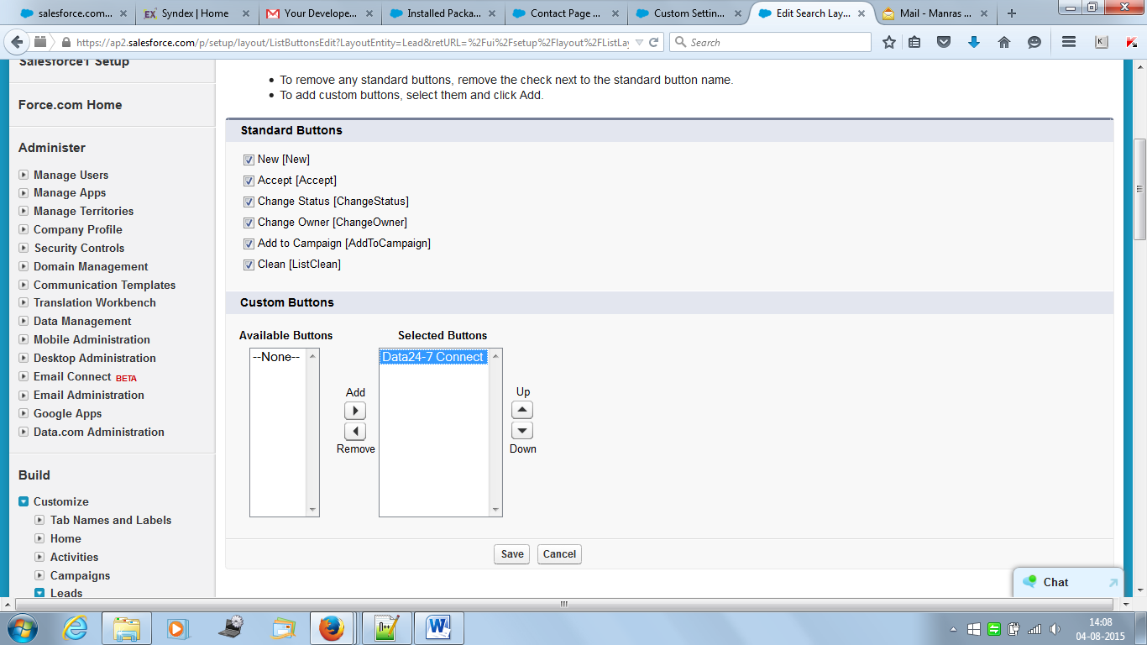
Save
Add Data24-7 Connect
- Setup->Build->Customize->Leads->Page Layouts
  - ->Click Edit(Lead Layout)
- Select Fields
- Add Carrier Id, Carrier name ,Wireless , MMS Address ,SMS Address to Lead Information Section.

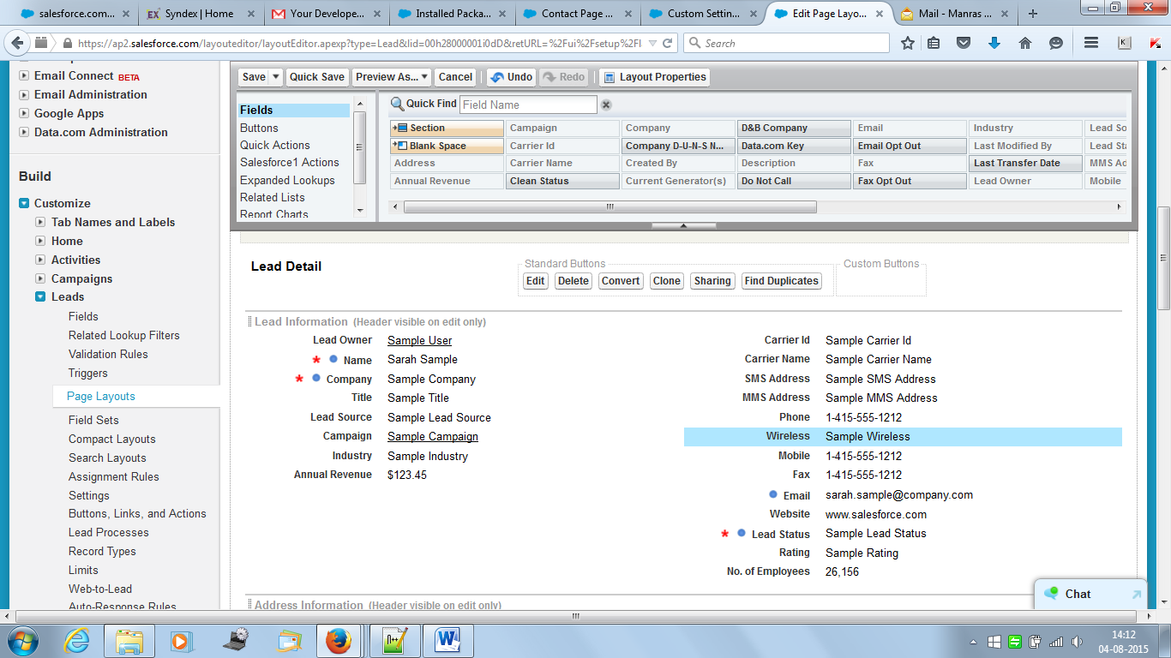

- Select Buttons
- Add Data24-7 Connect button to Custom Buttons of Lead Detail Page.
- Click Save

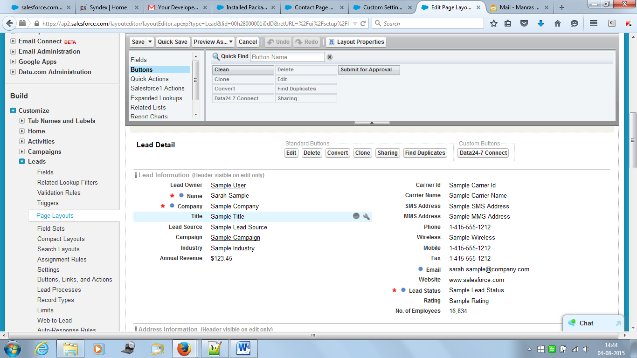

- Setup->Develop->Custom Settings->Manage
- Click New button.
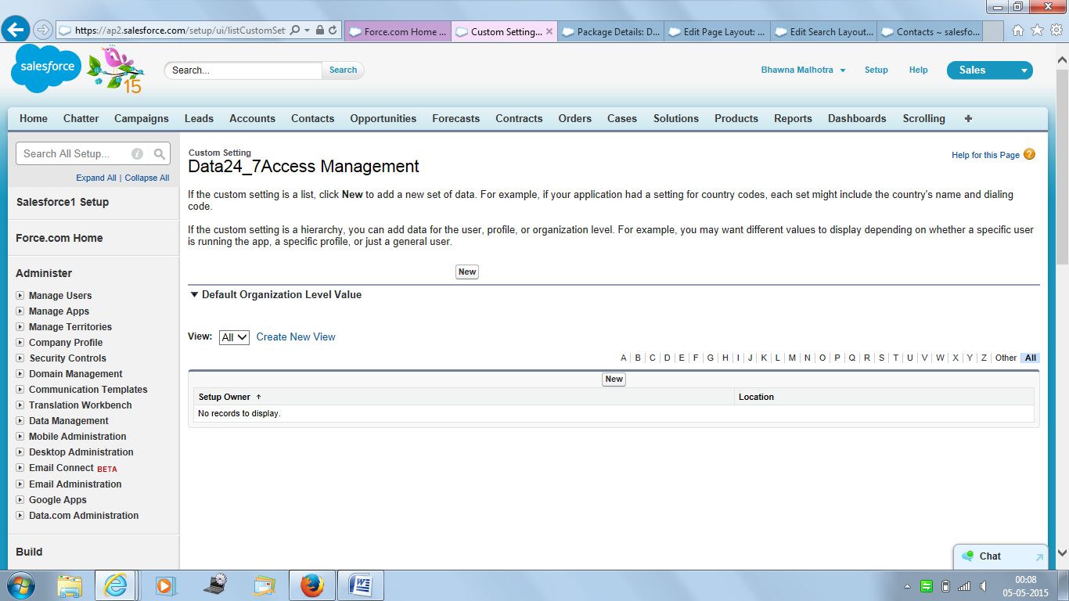
Click New

- Enter UserName and Password for the API.
- Click Save Button.
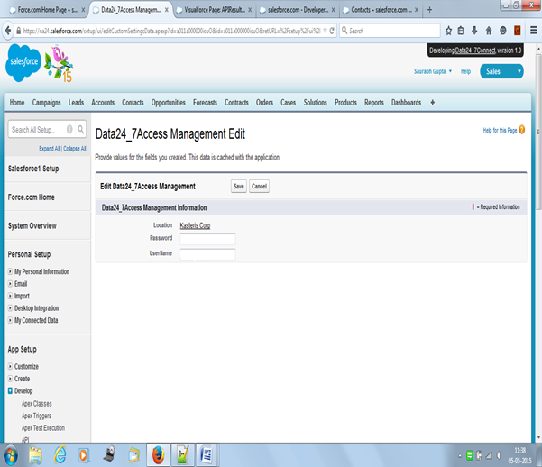
Save
Enter UserName and Password

- If above step (Data24_7Access Management Custom Settings) not performed than error occurs “Please contact your System Administrator to enter the necessary Data24_7AccessManagement Custom Setting values.” When you click Get Info button.

- Go to List View of Contact and select contacts.
- Click on Data24_7 Connect and a popUp is opened.
- Select a radio button than click Get Info button.

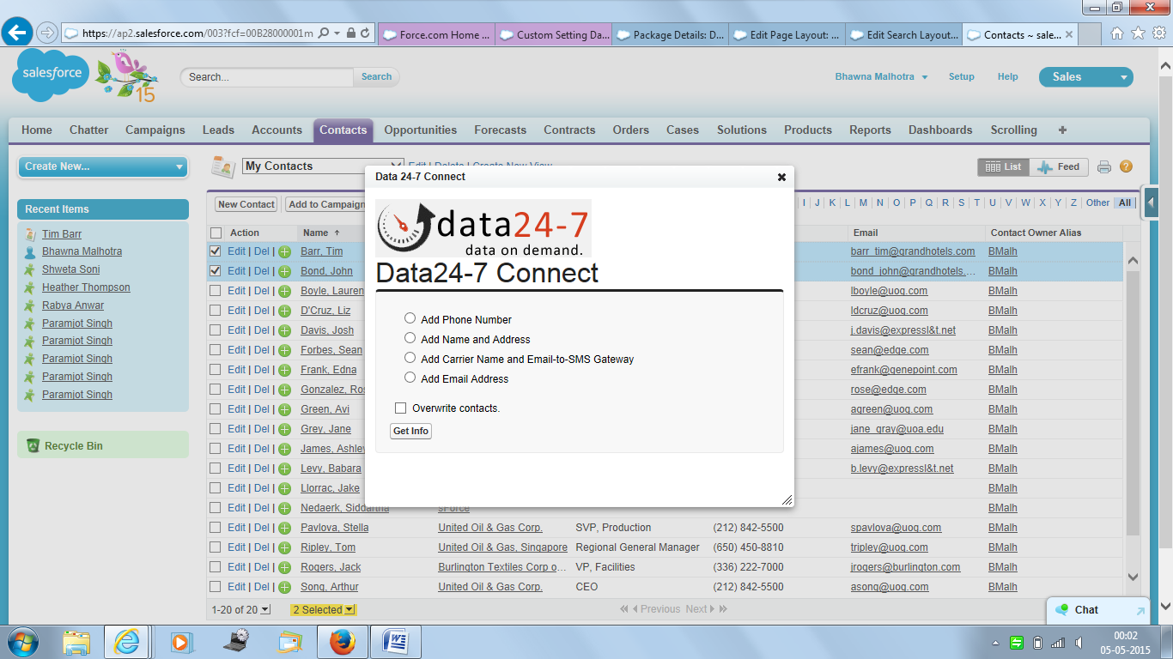
Click Get Info

